

16-19 Student Bursary Policy

The 16-19 Student Bursary Fund is a government-funded scheme, allowing payments to be made to students in financially challenging circumstances to support them in their post-16 learning. Students must meet certain school and government criteria in order to qualify. There are three types of bursary, all of which must be applied for through the school application system. Students will need to reapply for bursaries at the start of each academic year or provide a signed and dated self-declaration form to confirm that their household income has not changed from the time of their initial successful 16-19 bursary application.

The 16-19 Bursary is government-funded and the total fund is limited. Level 3 Bursaries will not be available once all funds have been allocated.

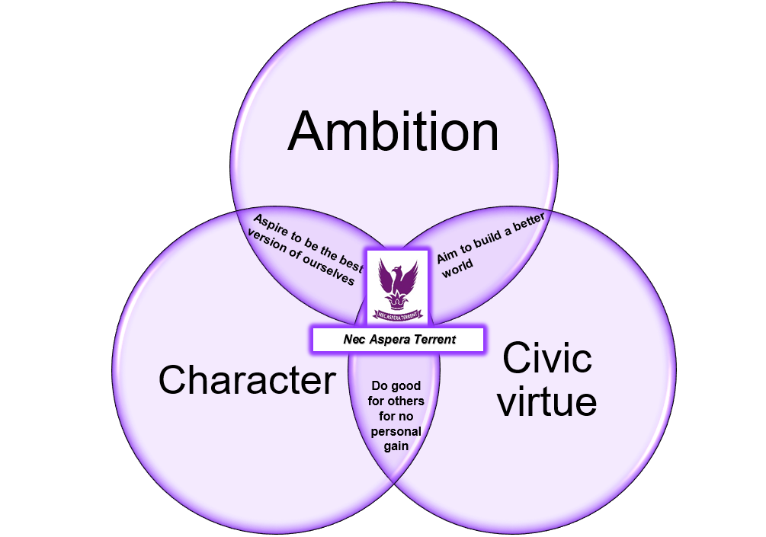

Last Reviewed – June 2024
Next Review – June 2025
Last Ratified – June 2024
Next Ratification – June 2025

Level 1 Bursary

Eligibility Criteria
Eligible students will be
- Young people in care or recent care leavers
- Young people independently in receipt of Income Support or Universal Credit
- Young people receiving Personal Independence Payment (PIP) in their own name and either ESA or Universal Credit
- Disabled young people in receipt of Income Support and Disability Living Allowance.
Evidence will be required

Amount of bursary: Up to £1200 per year
Payments: Five half-termly payments of £250
You may get the full amount if you have expenses and study full-time on a course of at least 30 weeks, subject to an assessment of financial needs. Students will receive an award letter informing them of the value of the bursary after the first review meeting and before the first payment is made.

Level 2 Bursary

Eligibility Criteria
- Students will currently be eligible for Free School Meals/will have received Free School Meals in the last six years or be from households in receipt of Universal Credit. An application must be made for Free School Meals (through the normal procedure, if not already assessed) and for the bursary.

Amount of bursary: Up to £500 per year, dependent on government funding and number of applicants.
You may get the full amount if you have expenses and study full-time on a course of at least 30 weeks, subject to an assessment of financial needs. Students will receive an award letter informing them of the value of the bursary after the first review meeting and before the first payment is made.
Payments: Five equal half-termly payments up to a maximum of £100 per half term.

Level 3 Bursary – Discretionary

Eligibility criteria
- Students will currently be eligible for Free School Meals/will have received Free School Meals in the last six years or be from households in receipt of Universal Credit. This bursary will be paid at the discretion of the Head of Sixth Form and is subject to sufficient funds remaining in the bursary fund.

Amount of bursary: Up to £300 per year, dependent on government funding and number of applicants.

Payments: One-off payments to cover specific expenses. Receipts/evidence will be required for expenses outside school. Payments for trips will be paid directly to the fund for that trip.

Please use separate Additional Bursary Expenses claim form.

Applying for the Bursary

Students should apply for the Level 1 and Level 2 Bursary as soon as possible in September, with Year 13 students expected to reapply if they remain eligible (or provide a signed and dated self-declaration form).

The deadline for Level 1 and Level 2 Bursary applications is the last school day in September. Applications made after this are not guaranteed to be successful and are subject to funds being available. A student can hold either a Level 1 or Level 2 Bursary.

Application forms can be obtained from the school website and Appendix 1. Completed applications should be given to the Head of Year and are treated in strict confidence.

Level 3 Bursary applications can be completed at any time but are subject to the availability of funds. An application for a Level 3 Bursary can be made in addition to holding a Level 1 or Level 2 Bursary.

Use of the Bursary

Level 1 and Level 2 Bursaries are provided to help students with costs linked to their education such as
- The cost of transport to school
- Food and drink during the school day/term
- Necessary equipment for study
- Appropriate clothing for school

Level 3 Bursaries are provided to help students with additional educational costs such as trips and visits, including those to universities or potential employers.

Bursary Review

Each half-term, the Head of Sixth Form and Head of Year will review all Level 1 and Level 2 Bursary students before payments are made.

Receiving a Level 1 or Level 2 Bursary each half-term is subject to students having:
- A minimum attendance in the previous half-term of 95%
- No unauthorised absences (including Private Study periods)
- A maximum of 5 late marks in the previous half-term
- A maximum of 10 behaviour points in the previous half-term

If any of these criteria are not met, a student will lose all or some of their bursary payment for the current half-term.

The first review meeting in the Autumn will determine which students are eligible for Level 1 and Level
2 Bursaries following the close of applications. All eligible students will receive their full Level 1 or Level 2 Bursary payment for the first half-term in the second half of the Autumn Term.

All subsequent review meetings will be used to determine whether students have satisfied the attendance and punctuality criteria and if payments should be withheld as a result. Students will be notified by the pastoral team as soon as is reasonably possible if a payment is to be withheld.

All Bursary payments must be made into a UK bank account in the name of the eligible student. Bursary payments cannot be made into bank accounts belonging to parents, carers or other relatives. The only exceptions are Level 3 Bursaries paid directly into a school trip account.

16-19 BURSARY APPLICATION FORM

Surname: ____________________ Forename: ___________________ Tutor Group: _________________

Date of Birth: ________________________________________________

Home Address: ______________________________________________________
______________________________________________________

Please answer the following questions (this information will be checked with the Local Authority).

- Please tick or fill in any that apply to you

Category
Are you a young person in care?
Are you a recent care leaver?
Are you a young person independently in receipt of Income Support or Universal Credit?
Are you a young person receiving Personal Independence Payment (PIP) in your own name and either ESA or Universal Credit?
Are you a disabled young person in receipt of income support and Disability Living Allowance?
Are you currently in receipt of Free School Meals?
Are you currently entitled to Free School Meals (but haven’t claimed yet)?
Have you received or been entitled to receive Free School Meals in the last 6 years?
Please state gross family/household income based on total annual take-home pay figure plus amount of Universal Credit (if applicable) received for the last three months.
What is the number of dependent children in the household
What are the requirements of study programme – full year / part year?
What is the distance from your home to school and method of travel?
You must provide appropriate evidence

- Level of bursary requested
- Level 1
- Level 2
- Level 3

- Bank details:

Account Holder’s Name
Bank Name
Sort Code
Account Number

Staff use only

Level of bursary requested
- Level 1
- Level 2
- Level 3

Eligibility checked Yes Please state if eligible for FSM/Ever 6/Provided evidence of take-home pay plus Universal Credit statement for the last three months (cross out whichever does not apply)

Assessment Categories

Household income | £0-£20,000  4 points | £20,001-£25,000  3 points | £25,001+  2 points
Number of dependent children | 3+ children  3 points | 2 children  2 points | 1 child  1 point
Distance from home to school | 3+ miles  3 points | 1 -3 miles  2 points | 1 mile or less  1 point

Bursary agreed Yes No

Level of bursary agreed
- Level 1 : £1,200 8-10 points
- Level 1 : £1,000 6-7 points
- Level 1 : £800 4–5 points

- Level 2 : £500 8-10 points
- Level 2 : £450 6-7 points
- Level 2 : £400 4-5 points

- Level 3

Multiplier –  Study programme requirements  (full time/part time) | Full time  100% of bursary awarded | Part time (Two term)  66% of bursary awarded | Part time (One term)  33% of bursary awarded

Student agreement signed, copy retained and given to student Yes

Amount agreed £

Regular payment or one off
Regular One off

Details recorded on spreadsheet
Yes

Details passed to Finance Office
Yes

BURSARY FUND
Student Agreement 2024/25

I agree to follow the procedures below in order for me to claim my half-termly bursary fund allowance.

You are expected to:
- Attend all lessons as detailed on your timetable and exams
- Ensure you are punctual to morning and afternoon registrations, all lessons and register your attendance
- Get permission in advance for any time you need to take off school by completing a Leave of Absence Request Form
- Follow the school absence procedure
- Ensure that your behaviour and effort meets with the school requirements, as laid out in the school’s behaviour policy and monitored by the school’s behaviour tracking systems
- Complete all homework and coursework in line with deadlines and to expected standards

Absence
Authorised Absence
It is understood that there is very occasionally, a reason why you may need to apply for permission to be absent by completing a Leave of Absence Form. It is up to the school to agree to this planned absence. If they agree in advance of the absence, then your payment will not be affected. The following list shows examples where permission may be granted on a limited basis

- Specialist medical appointments which cannot be arranged out of school hours
- Official university/college/employer interview or visit
- Work experience placement
- Participation in a significant extracurricular event
- Official religious observance
- Other events with agreed educational benefits

Unauthorised Absence
If you are absent without permission then you will not be eligible for full payment.
Reasons for absence which would not acceptable include

- Doctor/Dentist/Optician appointments. These should be made for out of school hours.
- Holidays
- Part or full time work which is not part of your programme of study
- Leisure activities
- Birthdays or similar celebrations
- Babysitting younger siblings
- Shopping
- Driving lessons or tests

Illness
If you are absent due to illness you may be eligible for payment as long as you adhere to the following
- Produce a letter explaining/authorising absence signed by parent/guardian on return to school
- Catch up with all work missed and provide confirmation from teachers that you have done so
- Any absence due to illness lasting longer than five days must be supported with a Doctor’s certificate

Behaviour or effort
If your behaviour or effort is deemed to have fallen short of the school’s expectations your payment will be withheld with immediate effect

Appealing a decision
Appeals against payment decisions must be made to Sixth Form reception within 14 days of the original decision, and any necessary evidence should be provided.

Student

Signed ……………………………………………………………………………………

Print Name …………………………………………………………………………..

Dated …………………………………………………………………………..

Sixth Form Administration

Signed …………………………………………………………………………………..

Print Name …………………………………………………………………………..

Dated …………………………………………………………………………..

